**Basic Menu**

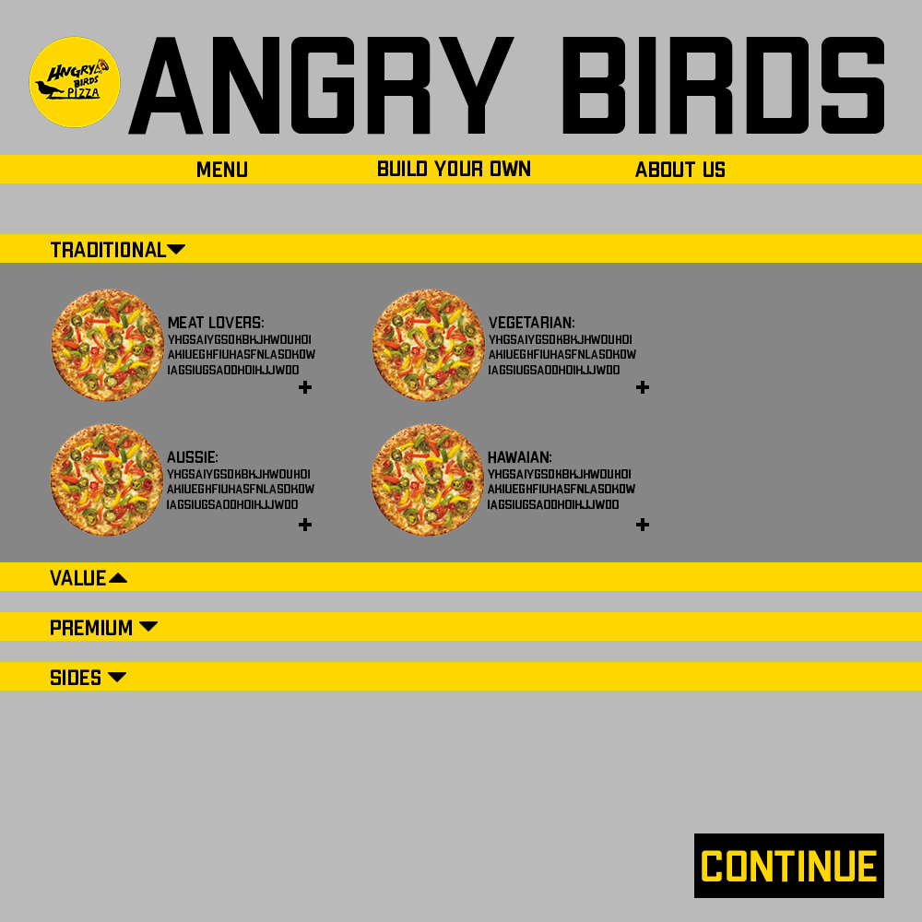

Figure 1: Hungry Bird’s Basic Menu Layout

Validation Testing:

In this page, the user will be shown various items that the user can choose from to buy. The items that is shown on this page are the usual items that the user would see in the other pizzeria websites, such as pre-made pizzas, snacks and drinks that are usually shown on the menu in a pizzeria.

To test this feature, we would make sure that each time the user selects the “+” (plus) sign, the responding item would be added to the checkout list (after going through the “Customise Existing Pizza” feature if applicable). we also utilise the “accordion” for this page so that the user is not exposed to irrelevant information that they might not want to see. To see whether this feature is successfully implemented, the information (i.e. the menu list) are shown only after the user clicked the corresponding option (for example, only show the “value” menu if the user clicked on it). The items that user also want to buy (by clicking the “+” sign) must also be added to the “cart”. Users then can review their orders before proceeding to checkout and hence also impact the information shown on the “Set Quantity” and “Place Order” main viable features.

**Customise Existing Pizza**

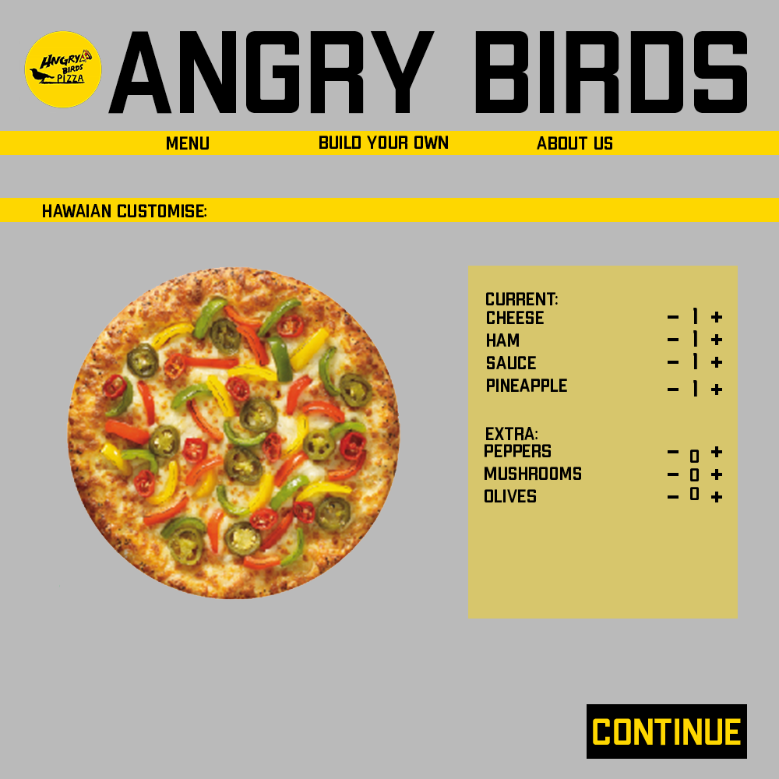

Figure 2: Hungry Bird’s “Add toppings” feature

Validation Testing:

After the user select an item from the menu, the user would be redirected to this page should the item the user choose is a pizza that is customisable. In this page, users can choose additional toppings if/that they would like to be added to their current pizza. As such, users would be shown items that can be added for the toppings along with their quantity. In addition, we also include the feature where we show users the picture of a pizza with the toppings that user choose.

For testing, we would want to make sure that users can add/remove toppings of their choosing (editing the quantity of the topping) by clicking the “+” or “-” sign which changes the picture of the pizza to also include the toppings corresponding to the user’s choice. To see whether the feature is successfully implemented, the number denoting a specific topping’s quantity would change in respond to users’ choice (add or remove). The picture of the pizza would also change accordingly to reflect on user’s choice of toppings. Moreover, the pizza would also be added to the checkout list (i.e. the user’s order list) along with the information of the toppings that the user want to add to it.